Web Authoring planning

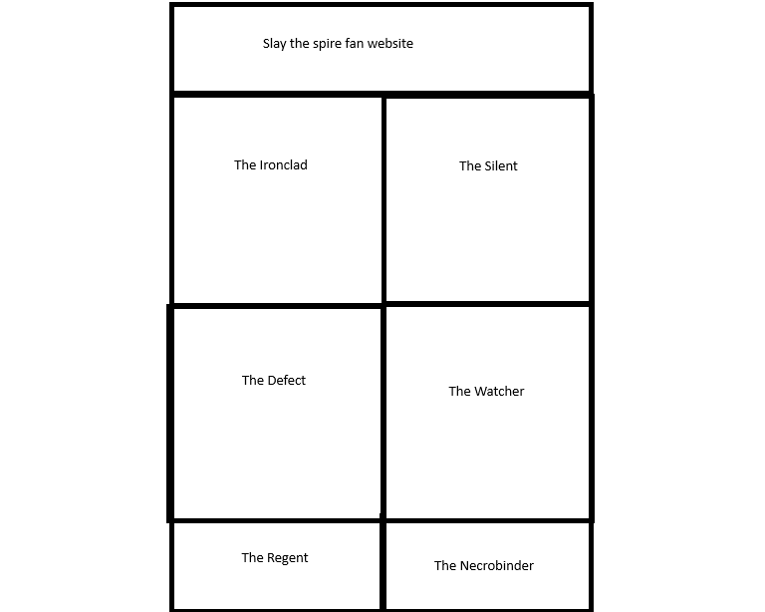
This will be the home page. Just a simple header with the title of the webpage.
It will have 6 boxes that can be clicked into to lead to different webapages of the playable characters.

The footer isn’t in this quick preview, but it will be in the final product
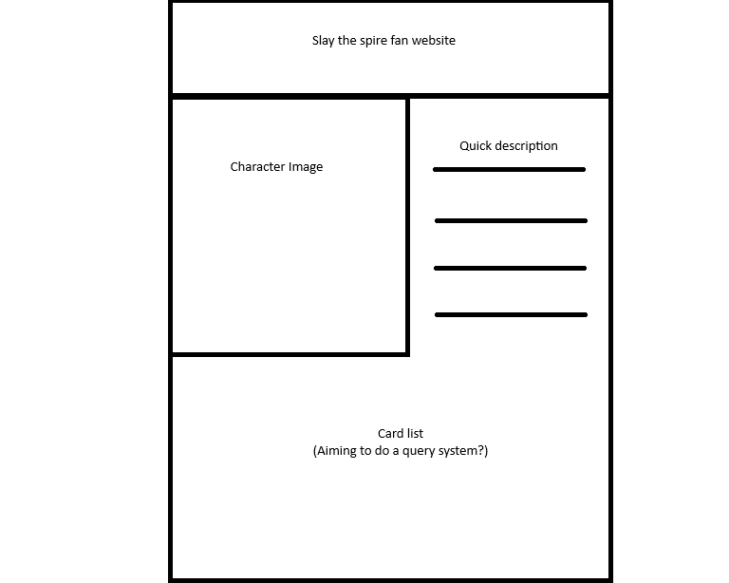

All 6 characters will have a page that looks like this.
It will feature they’re image, quick description, and card list.
At least one of these characters will have a card list I can query to fulfil the assignment requirements.

All images I gather will be screenshotted from the actual game.

